**During the last decade, Network Science has become important and a very active field. In this document we are concerned with doing analysis on football matches. As football is a very complex sport and a team game so viewing individual performance of a player would not do justice to the proper analysis of the match. In order to properly analyze a football match, we also have to analyze the team as a whole system. As it is a cliché said by players at post-match interview “It’s not just me, it’s the team.” There are coaches in soccer that live and breathe tactics and love to teach strategies to their players. Network Analysis of players passes can aid coaches to draft lineups and make tactics.**

Saad Yousaf

Take the ball pass the ball

# CONTENTS

I. INTRODUCTION 1

II. DATA GATHERING TECHNIQUES 1

III. DATASET STATISTICS 1

IV. GOALS 1

V. TECHNIQUE USED 1

VI. ANALYSIS 2

VII. CONCLUSION 3

# INTRODUCTION

We made a network of passes between players across various matches. The nodes represent players and the edges represent pass. After analysis we were able to see pattern in the tactics of the teams.

# DATA GATHERING TECHNIQUES

We gathered data by watching football matches. We made player to player matrix on excel sheet and wrote names of the players playing in the match. We viewed 3 matches of El Clasico and all goals of Barcelona against Real Madrid in recent 2 years. In first match we only recorded the passes of each players. In second match we recorded pass with holding pass having weightage one and attacking pass two. In third match we recorded attacking passes of a match and including goal as a node, with shot on target weighted as two and goal weighted as five. Fourthly we recorded passes leading up to a goal of Barcelona against Real Madrid of last 2 years. As data is recorded from a full football match and it is not a estimation so it cannot be unbiased.

# DATASET STATISTICS

The first match we recorded was El Clasico La Liga 2017/2018 leg 2. It had a total of 1,036 passes. Using this data, we got to know the pivotal player in passes, and which region of the player positions the most passes happen. In the second match we gave weight to attacking pass more than the holding pass, this way we know the pivotal player in creating the attack. In the third match we added a node of goal so that we highlight the passes that lead up to a shot on target or a goal. Fourthly we recorded all the goals of Barcelona against Real Madrid in recent 2 years, this way we would understand the combination of players or combination or passes that create most goals.

# GOALS

We analyze the playing style of the team. We analyzed how a team reacts to its opponents’ tactics. We identified the pivotal player in holding the ball, we identified the pivotal player in making attack, we identified the combination of players that create most goals.

# TECHNIQUE USED

The thickness and color of the edge depends on the weight of the edges, this will show which players have passed which players the most. This will also show the usual tactics by looking at the path of the ball.

The importance of each player has been related to: its degree, which is the number of passes made by a player. Importance of a player can also be related to: it’s betweenness centrality, which accounts to how many times a given player is necessary for completing the route.

# ANALYSIS

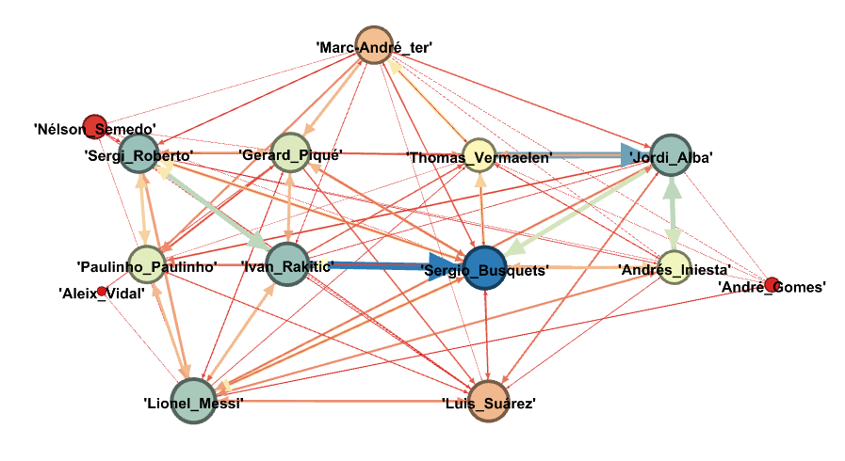

Figure 1Barca passing network el Clasico 2017

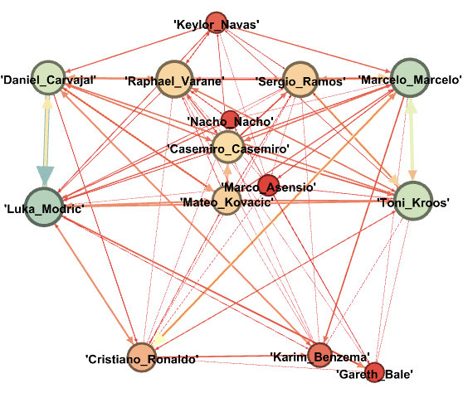

Figure 2Madrid passing network el Clasico 2017

In figure 1 the thickest edge is between Rakitic and Busquets which means most of the passing is done between them. We also analyzed that Barcelona played most of its passes in the center of the pitch and wing backs while figure 2 Real Madrid played most of its game on the wings, this could be because Barcelona playing center has forced Real Madrid to play on the wings as a counter tactic.

The node with the highest degree is Busquets, this means that he has made the most passes and he is very crucial in holding the ball and keeping possession for Barcelona.

For Real Madrid Modric, Kroos and Marcelo have made the most passes. This shows that Real Madrid is not dependent on any one player to hold the ball for them and keeping procession.

We also analyzed that both teams attack from the right side of the pitch this could be because both of their dominant players Ronaldo and Messi were playing on the right side of the pitch.

We can observe that Suarez has less importance in figure1 of passing network, but this does not do justice to his performance he displayed during the match. In order to better analyze the performance of the players we gave attacking pass double weightage than a holding pass when recording data for the next match.

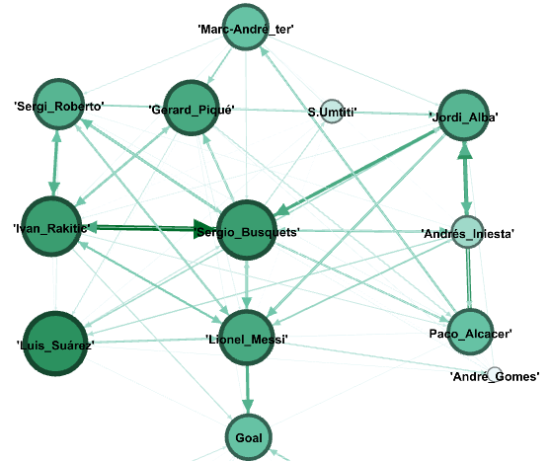

Figure 3Barca passing network Inter Champions cup final

In figure 3 we can observe similarity from the previous match in figure 1 even though few of the players are changed. In figure 3 after considering the weightage of an attacking pass more than a holding pass, we see Suarez becomes a dominate player giving us true depiction of his performance during the game. We can again analyze in figure 3 that the right side of Barcelona is more dominant in this game. We can also clearly see that much of the attack is led by Messi receiving the ball from different players and going for the goal.

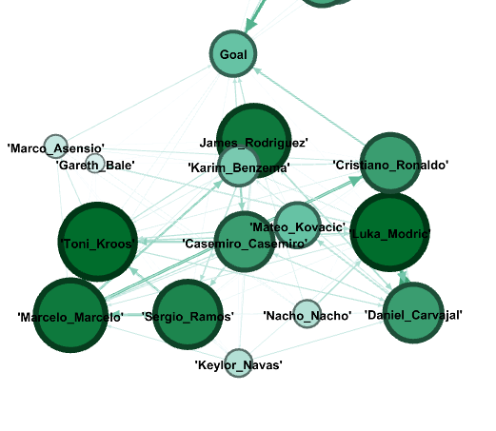

Figure 4Madrid passing network Inter Champions cup final

We can clearly see the thickest edge is between Marcelo and Ronaldo; the diagonal pass, this show the connection between the two players even though they are playing in diagonal corners of the pitch. This also shows that Real Madrid plays more long balls rather than short passes and their players make runs more frequently.

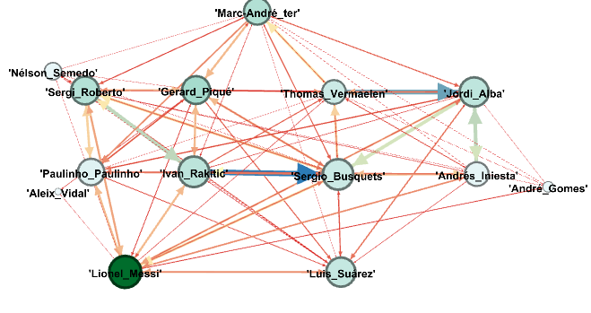

Figure 5 Barca Passing Matrix with betweenness

In figure 5 we used central betweenness to represent the player necessary to complete the route of the ball. We have Messi with the most betweenness as he is a box to box player, he connects the attack with the midfield. In order for the ball to reach the strikers Messi become a pivotal player or a bridge to between the striker and the midfielder.

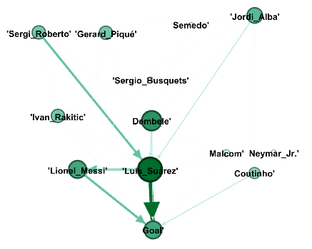

Figure 6 Barca all goals against Madrid in 2017-2018-2019

From the figure 6 we can see the combination of passes that lead to goal against Real Madrid in recent 3 years. We can see that Suarez plays a very important role in creating goals against Real Madrid. Looking at figure 6 we realize that Barcelona’s wing backs play an important role in initiating the attack that lead up to goal.

Dembele has been criticized for lack of performance but the figure 6 show another aspect of why you need to keep Dembele in Barcelona against Real Madrid. When it comes to goals against Real Madrid Dembele played an important role in initiating the attack that lead up to goals.

# CONCLUSION

Although we analyzed from figure 1 and figure 3 that Busquets plays important role to hold the ball and keep possession but when it comes to goals Busquets has very minimum role in making the attack that lead up to a goal. **This begs for the classical debate in football; Is high possession and too much passes really worth it when you are not contributing in scoring goals.**